**CNN working procedure**

To demonstrate how to build a convolutional neural network based image classifier, we shall build a 6 layer neural network that will identify and separate one image from other. This network that we shall build is a very small network that we can run on a CPU as well. Traditional neural networks that are very good at doing image classification have many more parameters and take a lot of time if trained on normal CPU. However, our objective is to show how to build a real-world convolutional neural network using TENSORFLOW.

Neural Networks are essentially mathematical models to solve an optimization problem. They are made of neurons, the basic computation unit of neural networks. A neuron takes an input (say x), do some computation on it (say: multiply it with a variable w and adds another variable b) to produce a value (say; z= wx+b). This value is passed to a non-linear function called activation function (f) to produce the final output(activation) of a neuron. There are many kinds of activation functions. One of the popular activation function is Sigmoid. The neuron which uses sigmoid function as an activation function will be called sigmoid neuron. Depending on the activation functions, neurons are named and there are many kinds of them like RELU, TanH.

If you stack neurons in a single line, it’s called a layer; which is the next building block of neural networks. See below image with layers

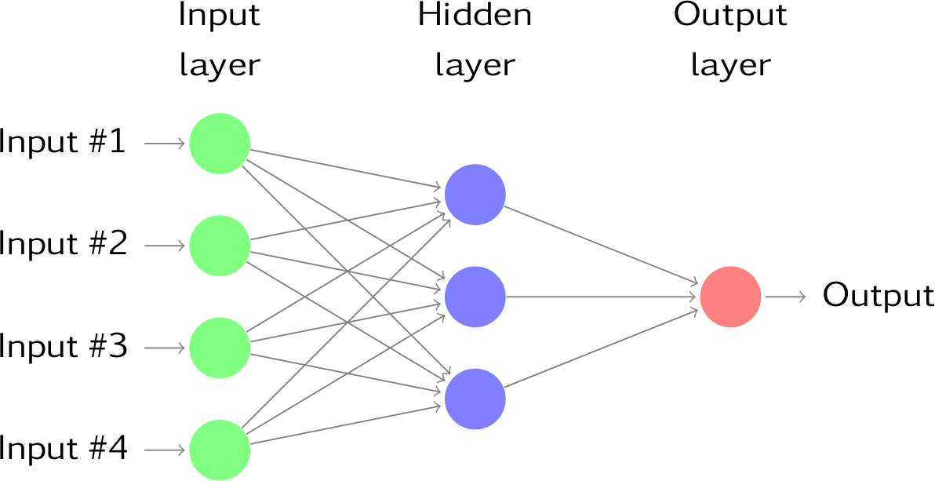

To predict image class multiple layers operate on each other to get best match layer and this process continues till no more improvement left.